
EXECUTIVE GAME THEORY CURRICULUM • 12-WEEK MASTER ARCHITECTURE
Lesson 01: The Strategic Mindset — Intuitive Reinforcement & Inversion
The Inversion Reflex: Cognitive Hierarchy, Level-k Rationality, and Overcoming the Illusion of Secrecy
Strategic Focus & Learning Objective: In this topic, we will be learning how to apply Cognitive Hierarchy Theory (Level-k Reasoning) and Strategic Inversion to solve the Pre-Dawn Operational Escalation Trap (First-Order Myopic Competition).
The Real-World Operational Problem: Enterprise founders and operational executives repeatedly fall into exhausting, capital-draining competitive standoffs because they suffer from First-Order Myopia: they ask 'What advantage do I gain by moving first?' without asking 'What is my rival's immediate counter-move, and what does that force me to do next?' Unilateral tactical escalation leads directly to mutual resource exhaustion with zero permanent competitive differentiation.
How This Topic Solves It: Cognitive Hierarchy Theory and the Inversion Reflex solve this by providing leaders with a structured Two-Move Inquiry Protocol. Instead of assuming secrecy or competitor complacency (Level-1 thinking), leaders model how a rational counterparty will neutralize the initiative (Level-2 thinking). If the second-order equilibrium leaves both parties worse off, the executive eliminates the wasted operational overhead in advance and pivots to asymmetric moats.
■ EXECUTIVE INVERSION ADVISORY
Effective strategists invert the traditional inquiry: 'What is my rival likely to do in response to my choice, and how does that position our organization afterwards?' Never build a plan that depends on competitors failing to notice your operational moves or failing to act rationally.

Orientation — Where We Are & What We Are About to Do: Having mastered the four formal primitives (N, S, u, I), we now examine the psychological blind spots that cause leaders to sabotage themselves in competitive markets. In Part I, we witness two rival bakeries bleed cash in an uncoordinated pre-dawn escalation. In Part II, we build the Inversion Reflex across seven structured stages.
Part I: The 4-Part Prelude Protocol
1. Models in Focus: Cognitive Hierarchy Theory (Level-0, Level-1, Level-2), Strategic Inversion Mechanics, and the Illusion of Operational Secrecy.
2. Lifelike Dilemma & Problem Statement: An artisanal downtown bakery notices intense morning foot traffic at 7:00 AM. To capture early commuters, the owner opens 2 hours earlier at 5:00 AM, spending $4,000/month on extra baking shift labor. One week later, the rival bakery across the street opens at 4:45 AM. Both bakers now work exhausting pre-dawn shifts, foot traffic splits evenly, and neither earns enough incremental margin to cover overtime wages.
3. Component Dissection: The bakery owner exhibited Level-1 Thinking ('I will open early and take all the commuters') while failing to apply Level-2 Thinking ('My competitor will see me opening early and pre-empt me').
4. Lesson Embarkation: We subject strategic decisions to psychological inversion, examining how human decision-makers reason under competitive pressure.
Part II: The 7-Stage Core Pedagogy
Stage 1: Why Learn This (Overcoming First-Order Myopia)
Most corporate blunders stem from First-Order Myopia—stopping the analysis after the first move. Developing the Inversion Reflex forces you to evaluate tactical options through the lens of competitor counter-responses before committing capital.
▼ CHECKPOINT: WHAT YOU MUST KNOW BEFORE MOVING FORWARD
Stopping after step one is the most expensive mistake in business. Always ask: 'And then what happens?' If your advantage only works if the other party does nothing, your idea is dead on arrival.

Stage 2: The 5-Minute Core Framework (The Hierarchy of Thinking)
Strategic depth is measured by how many layers of reciprocal reaction an executive models:
Cognitive Level | Mental Model & Behavioral Signature | Real-World Corporate Manifestation
Level-0 (Impulse / Inertia) | Acts on pure reflex, habit, or mechanical routine without counterparty awareness. | Slashing prices simply because inventory is high, ignoring competitor price triggers.
Level-1 (Myopic Optimizer) | Assumes all other market players are static Level-0 actors and optimizes against them. | Horizon Air cutting fares by 25%, assuming Metro Jet will passively surrender share.
Level-2 (Strategic Anticipator) | Anticipates that competitors are Level-1 optimizers and models their best countermoves. | Anticipating an instant fare match and locking in enterprise contracts instead.

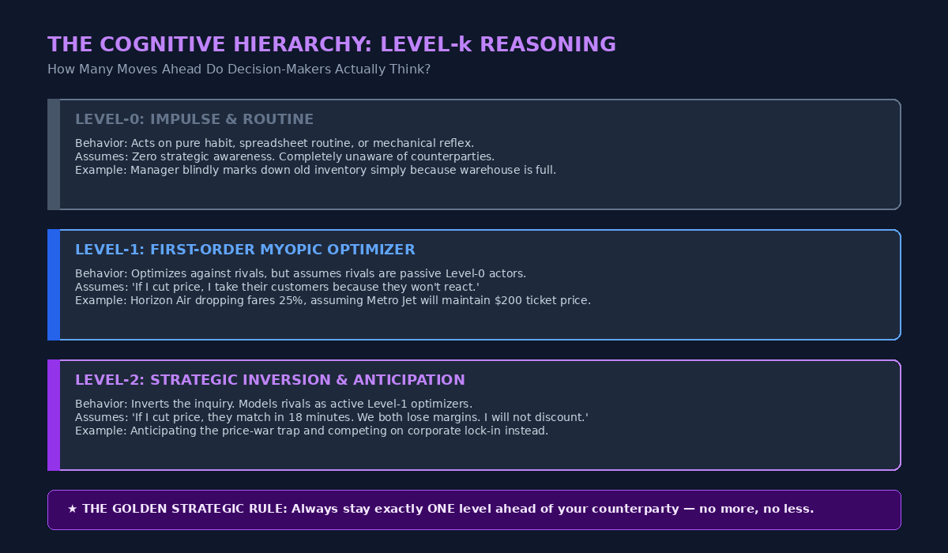
Figure 1B: The Cognitive Hierarchy Framework (Level-k Thinking & Strategic Inversion)
▼ CHECKPOINT: WHAT YOU MUST KNOW BEFORE MOVING FORWARD
Level-0 acts blindly; Level-1 thinks everyone else is asleep; Level-2 knows competitors are awake, hungry, and optimizing. Aim to stay exactly one level ahead of your rival—no more, no less.

Stage 3: The 3-Layered Operational Deep Dive
Layer 1 — The Mechanical Protocol (Two-Move Self-Inquiry): Move 1 Response: 'If we execute Move A, what is the rival's cheapest, most effective countermeasure (Move B)?' Move 2 Viability: 'When they execute Move B, what is our counter-response (Move C), and does the business case still hold?'
Layer 2 — The Cognitive Failure Mode (The Illusion of Secrecy): Never assume internal plans, supplier trials, or pilot discounts will stay hidden in connected supply chains.
Layer 3 — Boundary Considerations: Account for state-backed or venture-subsidized rivals who may prioritize market disruption over short-term profit.
▼ CHECKPOINT: WHAT YOU MUST KNOW BEFORE MOVING FORWARD
Your boardroom secrets are never as private as you think. Run the Two-Move Test in daylight: if they find out on day one and make their cheapest countermove, do you still make money?

Stage 4: Real-World Applications × 3
1. Commercial Real Estate Leasing: A landlord offered 6 months free rent to poach a prime tenant; the rival landlord matched with 9 months free rent, depressing both building valuations.
2. Municipal Infrastructure & Traffic Policy: Speed bumps on a boulevard caused drivers to divert into narrow residential alleys, raising municipal accidents by 14%.
3. Enterprise Cross-Departmental Politics: Sales hoarded leads from Customer Success to claim expansion bonuses; Customer Success delayed onboarding handoffs, spiking churn.
▼ CHECKPOINT: WHAT YOU MUST KNOW BEFORE MOVING FORWARD
Unilateral escalation in discounts, speed bumps, or turf wars creates mutual exhaustion. When both sides fight for the same pie with identical weapons, nobody wins except the bystander.

Stage 5: Diagnostic Self-Quiz & Evaluative Rubric
Scenario: A retail bank proposes a $300 cash bonus for new checking accounts to poach 50,000 accounts from its rival. What is the Level-2 flaw? (A) $300 is too low; (B) The rival bank will match with a $350 bonus within days, leaving core balances unchanged while both bleed cash to churners; (C) AML compliance costs; (D) Branch staffing limits.
Recommended Answer — B: Retail banking retention teams counter-match acquisition bonuses immediately, turning unilateral cash giveaways into a mutual fee drain.
▼ CHECKPOINT: WHAT YOU MUST KNOW BEFORE MOVING FORWARD
Testing your second-order reflex means asking: 'What stops my competitor from matching my offer tomorrow morning?' If the answer is 'nothing,' you are subsidizing churn.

Stage 6: What You Should Know by Now (Daily Life Translation)
■ THE DAILY LIFE TRANSLATION
Level-1 thinking is tailgating a slow car on the highway because you want to go faster. Level-2 thinking is realizing that tailgating causes the driver ahead to tap their brakes out of annoyance, forcing you to brake harder and creating a phantom traffic jam. Leaving space preserves your own forward momentum.

▼ CHECKPOINT: WHAT YOU MUST KNOW BEFORE MOVING FORWARD
Crowding the driver in front just makes them slam on the brakes. Giving your opponent room to make predictable choices gets you to your destination faster.

Stage 7: Self-Regulated Practice & Interactive Discovery
Self-Regulated Learning Note: All benchmarks provided in this module are advisory self-regulation guidelines. Benchmark your reflections against Level-2 strategic anticipation, then launch the companion simulation engines below.
▼ CHECKPOINT: WHAT YOU MUST KNOW BEFORE MOVING FORWARD
You now possess the strategic mindset: look forward, reason backward, respect your rival's reflexes, and never launch a move that collapses under its own second step.

Topic 01 Companion Games: Operational Briefing & Deployment
1. Pedagogical Intent: Transform theoretical strategic interdependence and normal-form reasoning into instinctive, board-ready reflexes through twin browser-based simulation engines hosted on GitHub Pages.
2. Executive Objectives: Game 1 (Intercept Runner) tests real-time reflex dodging against reactive algorithmic interceptors while harvesting capital yield. Game 2 (Commuter Route Fare War) places you at the helm of AeroTransit across a 3-round commercial pricing standoff against reactive competitor algorithms.
3. Core Mechanics & Scoring Standards: Answering the pre-flight strategic calibration quiz in Game 1 unlocks a 200% Entry Energy Buff and Kinetic Shield. Game 2 (Simulation Quiz) carries DOUBLE WEIGHT (2x) on the unified master leaderboard: Overall Score = Video Game Score + (2 × Simulation Quiz Score).
4. How to Play & Controls: Desktop: Use Arrow Keys or WASD for vehicle maneuvering, and mouse click to commit pricing choices. Mobile: Tap Left/Right touch quadrants to steer, and tap scenario fare buttons to commit moves.
5. Live Deployment & Playable Links (Calculated from Repository Path & Planned Filenames):
• Game 1 (Intercept Runner Arcade): https://firedancerx.github.io/Game-Theory/Games/Lesson%2001/game1_intercept_runner.html
• Game 2 (Commuter Route Fare War Simulation): https://firedancerx.github.io/Game-Theory/Games/Lesson%2001/game2_commuter_route_fare_war.html
• Master Platform Portal & Leaderboard Hub: https://firedancerx.github.io/Game-Theory/
Appendix: Obsidian Knowledge Graph Semantic Triplets
To empower lifelong retrieval and direct integration into enterprise Personal Knowledge Management (PKM) vaults (Obsidian / Logseq), the fundamental models of this lesson are formalized into atomic semantic triplets (Subject -> Predicate -> Object).
%% Obsidian Raw Semantic Triplets (Copy & Paste into Vault) %%
[[Game Theory]] --[formalizes]--> [[Strategic Interdependence]]
[[Game Theory]] --[requires]--> [[Interactive Rationality]]
[[Game Theory]] --[solves]--> [[Boardroom Conflict]]
[[Game Primitives]] --[defines]--> [[Interaction Rules]]
[[Players (N)]] --[executes]--> [[Strategies (S)]]
[[Payoffs (u)]] --[governed_by]--> [[Information (I)]]
[[Payoff Matrix]] --[models]--> [[Simultaneous Move Game]]
[[Payoff Matrix]] --[maps]--> [[Strategy Collision Profiles]]
[[Payoff Matrix]] --[uses]--> [[Ordinal Utility]]
[[Level-k Thinking]] --[bounds]--> [[Human Depth of Reasoning]]
[[Level-0]] --[acts]--> [[Randomly/Naively]]
[[Level-k Strategic]] --[exploits]--> [[Level-(k-1) Predictable Patterns]]
[[Unilateral Reaction Test (URT)]] --[audits]--> [[Counterparty Reaction Latency]]
[[Instant Retaliation]] --[collapses]--> [[Unilateral Margins]]
[[Defensible Moats]] --[immunizes_against]--> [[Price Wars]]

Concept Entity | Historical Origin & Date | Obsidian Semantic Triplets (Subject -> Predicate -> Object) | Executive Commercial Meaning
[[Game Theory]] | John von Neumann & Oskar Morgenstern (1944) | [[Game Theory]] --[formalizes]--> [[Strategic Interdependence]]  [[Game Theory]] --[requires]--> [[Interactive Rationality]] | Science of predicting counterparty moves before investing capital.
[[Game Primitives (N,S,u,I)]] | Von Neumann & Morgenstern (1944) | [[Game Primitives]] --[defines]--> [[Interaction Rules]]  [[Players (N)]] --[executes]--> [[Strategies (S)]] | The 4 irreducible parameters required to scope any business rivalry.
[[Payoff Matrix]] | Émile Borel (1921), Formalized 1944 | [[Payoff Matrix]] --[models]--> [[Simultaneous Move Game]]  [[Payoff Matrix]] --[uses]--> [[Ordinal Utility]] | Grid mapping mutual profits, losses, and strategic collisions.
[[Level-k Thinking]] | Rosemarie Nagel (1995), Stahl & Wilson (1994) | [[Level-k Thinking]] --[bounds]--> [[Human Depth of Reasoning]]  [[Level-k Strategic]] --[exploits]--> [[Level-(k-1) Patterns]] | Calculating exactly how many steps ahead your human rival actually thinks.
[[Unilateral Reaction Test (URT)]] | Executive Game Theory Standard (2026) | [[URT Protocol]] --[audits]--> [[Counterparty Reaction Latency]]  [[Defensible Moats]] --[immunizes_against]--> [[Price Wars]] | Boardroom self-audit testing whether discounts survive competitor matching.

